

**International School**

**Capstone Project 2**

**CMU-SE 451 – C2SE.12**

**Interface design Document**

**Version 1.1**

**Date: March 6th, 2021**

**Learn English Together**

**Submitted by**

**Ha, Le Thanh**

**Hieu, Le Xuan**

**My, Ngo Ngoc**

**Thong, Doan Trung**

**Approved by**

**MSc Huy, Truong Dinh**

**Proposal Review Panel Representative:**

Name Signature Date

**Capstone Project 2- Mentor:**

Name Signature Date

**PROJECT INFORMATION**

|  |  |  |  |
| --- | --- | --- | --- |
| **Project acronym** | LET | | |
| **Project Title** | Learn English Together | | |
| **Start Date** | 26 Feb 2021 | **End Date** | 08 Jun 2021 |
| **Lead Institution** | International School, Duy Tan University | | |
| **Project Mentor** | MSc Huy, Truong Dinh | | |
| **Scrum master / Project Leader & contact details** | Ha, Le Thanh  Email: lethanhhadtu@gmail.com  Tel: 0334002818 | | |
| **Partner Organization** | Duy Tan University | | |
| **Project Web URL** |  | | |
| **Team members** | Name | Email | Tel |
|  | Ha, Le Thanh | lethanhhadtu@gmail.com | 0334002818 |
|  | Hieu, Le Xuan | xuanhieu.le.1999@gmail.com | 0399706614 |
|  | My, Ngo Ngoc | ngongocmy851999@gmail.com | 0764497391 |
|  | Thong, Doan Trung | doanthong002@gmail.com | 0886428208 |

REVISION HISTORY

| **Version** | **Date** | **Comments** | **Author** |
| --- | --- | --- | --- |
| 1.0 | March 6th, 2021 | Initial Release | H2MT Team |
| 1.1 | March 13th, 2021 | Update Current Status of Art | H2MT Team |

TABLE OF CONTENT

1. Introduction 5

1.1. Purpose 5

1.2. Scope 5

2. Interface Design 5

2.1. Home page 5

2.2. Navbar 6

2.3. Footer 6

2.4. Group 7

2.4.1. Topic 7

2.4.2. Group of topic 7

2.4.3. Detail group 8

2.5. Profile 10

2.6. Live stream 10

2.7. Chat 10

1. Introduction

1.1. Purpose

This specification covers following:

* Documentation helps to better understand the user interface of the website, the detailed description and functionality of the website.
* With this documentation, the development team can understand the structure and composition details to create a consistent and complete system.

1.2. Scope

* Overview of the stages and modules of the software.
* Create complete interface and describe them clearly.

2. Interface Design

2.1. Home page

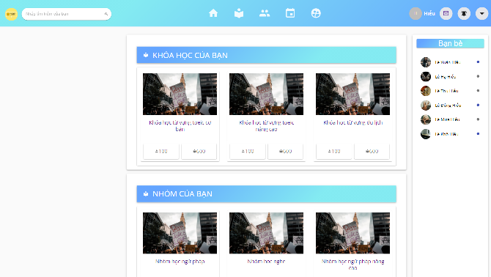

|  |  |  |  |  |
| --- | --- | --- | --- | --- |
| **Homepage** | | | | |
| **No.** | **Field name** | **Type** | **Require** | **Target** |
| 1 | Background |  | Background: #101522 |  |
| 2 | My Courses | Grid View | Heading: h2 tag  Font-size: 20px color:  Button: members | list of courses you have taken |
| 3 | My Groups | Grid view | Heading h2 tag  Font-size: 20px color:  Images group, topic group: : font-size: 13px |  |
| 4 | My friend |  | Padding: 10 20px Color: #fff  Font-size: 13px; | Friend online |

2.2. Navbar



|  |  |  |  |  |
| --- | --- | --- | --- | --- |
| **Navbar** | | | | |
| **No.** | **Field name** | **Type** | **Require** | **Target** |
| 1 | Logo | Image |  | Logo.png |
| 2 | Menu | List | Height: 60px; Font-size: 19px; Font-family: “Source sans pro”.  Responsive: max-width: 960px; | Search, home, group, event, random assistance, login/logout, notification |

2.3. Footer

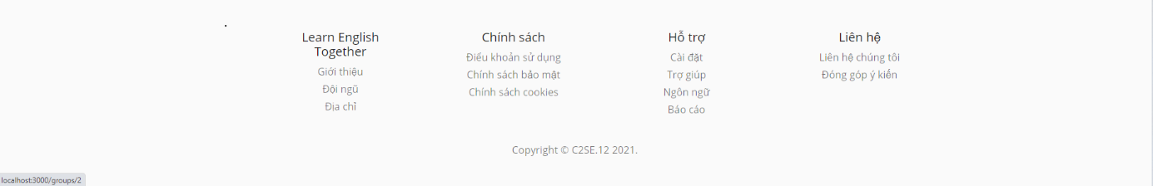

|  |  |  |  |  |
| --- | --- | --- | --- | --- |
| **Footer** | | | | |
| **No.** | **Field name** | **Type** | **Require** | **Target** |
| 1 | About web |  | Font-size: 15px | Learning English together, support, contact, policy |
| 2 | Credits | P tag | Font-size: 15px; Font-family: “source sans pro” Responsive: 960px | Copyright © C2SE.12 2021 |

2.4. Group

2.4.1. Topic

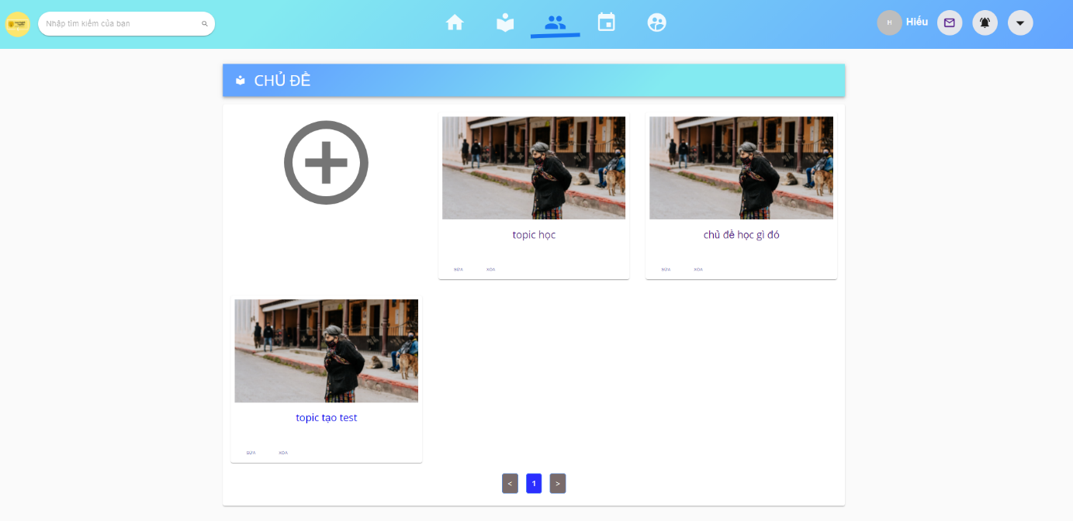

|  |  |  |  |  |
| --- | --- | --- | --- | --- |
| **Topic** | | | | |
| **No.** | **Field name** | **Type** | **Require** | **Target** |
| 1 | Heading | H1 tag | Font-size: 20px  Background: color blue | Topic |
| 2 | Topic |  | Image topic  Name topic font-size:13px color blue | When onClick name topic, list group topic |
| 3 | Next page | ul tag | Color: blue  Font-size : 13px | Number page and button next page |

2.4.2. Group of topic

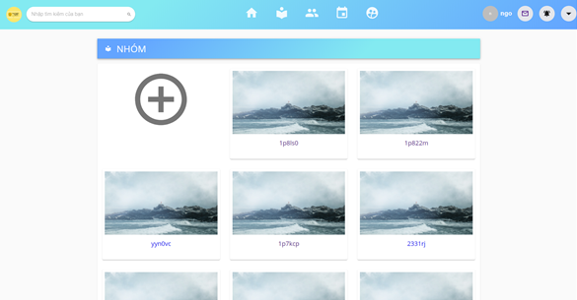

|  |  |  |  |  |
| --- | --- | --- | --- | --- |
| **Group of topic** | | | | |
| **No.** | **Field name** | **Type** | **Require** | **Target** |
| 1 | Heading | H1 tag | Font-size: 20px | Topic |
| 2 | Group |  | Image group  Name group font-size:13px color blue | When onClick name group, detail of group |
| 3 | Next page | ul tag | Color: blue  Font-size : 13px | Number page and button next page |

2.4.3. Detail group

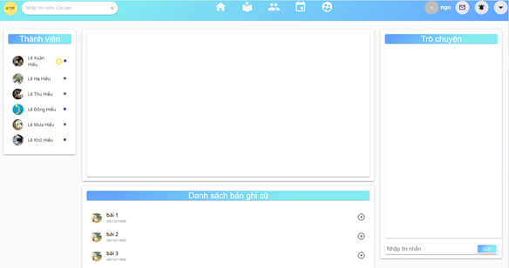

|  |  |  |  |  |
| --- | --- | --- | --- | --- |
| **Detail group** | | | | |
| **No.** | **Field name** | **Type** | **Require** | **Target** |
| 1 | Member | List | Heading: h2 tag background blue  Position: left screen  Avatar member and name ember: font-size 13px | Member group |
| 2 | Video courses |  | Heading: h2 tag background blue  Position: center Screen | the video has been recorded |
| 3 | Chat room |  | Heading: h2 tag background blue;  Position: right screen;  Content chat: font-size: 13px;  Input box: width : 100px, height : 20px;  Button send: background: blue |  |
| 4 | List video course | List | Heading: h2 tag background blue;  Position: Below video courses | List video has been recorded |

2.5. Profile

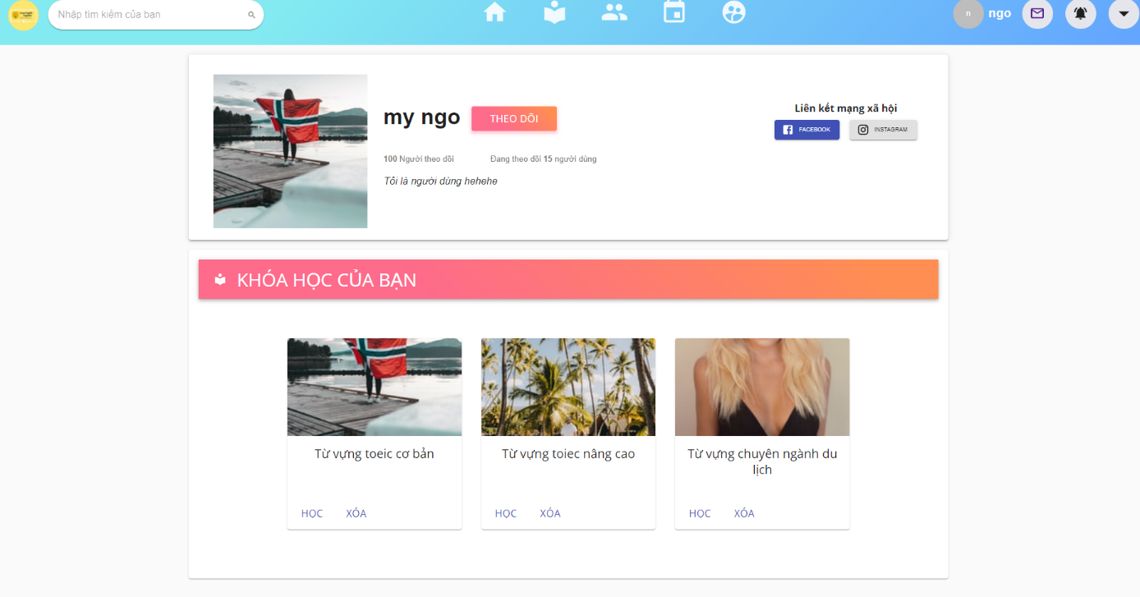

|  |  |  |  |  |
| --- | --- | --- | --- | --- |
| **Profile** | | | | |
| **No.** | **Field name** | **Type** | **Require** | **Target** |
| 1 | Avatar | image | Font-size: 250px | Avatar of user |
| 2 | Username | P tag | Font-size: 13px;  Font-weight: bold |  |
| 3 | My Courses | Grid View | Heading: h2 tag  Font-size: 20px color:  Button: learn and delete course | list of courses you have taken |
| 4 | Follow | Button | Font-size: 13px;  Background color: orange; | When others click, they will follow you |
| 5 | Followers | P tag | Font-size: 13px | Show tracking number |

2.6. Live stream

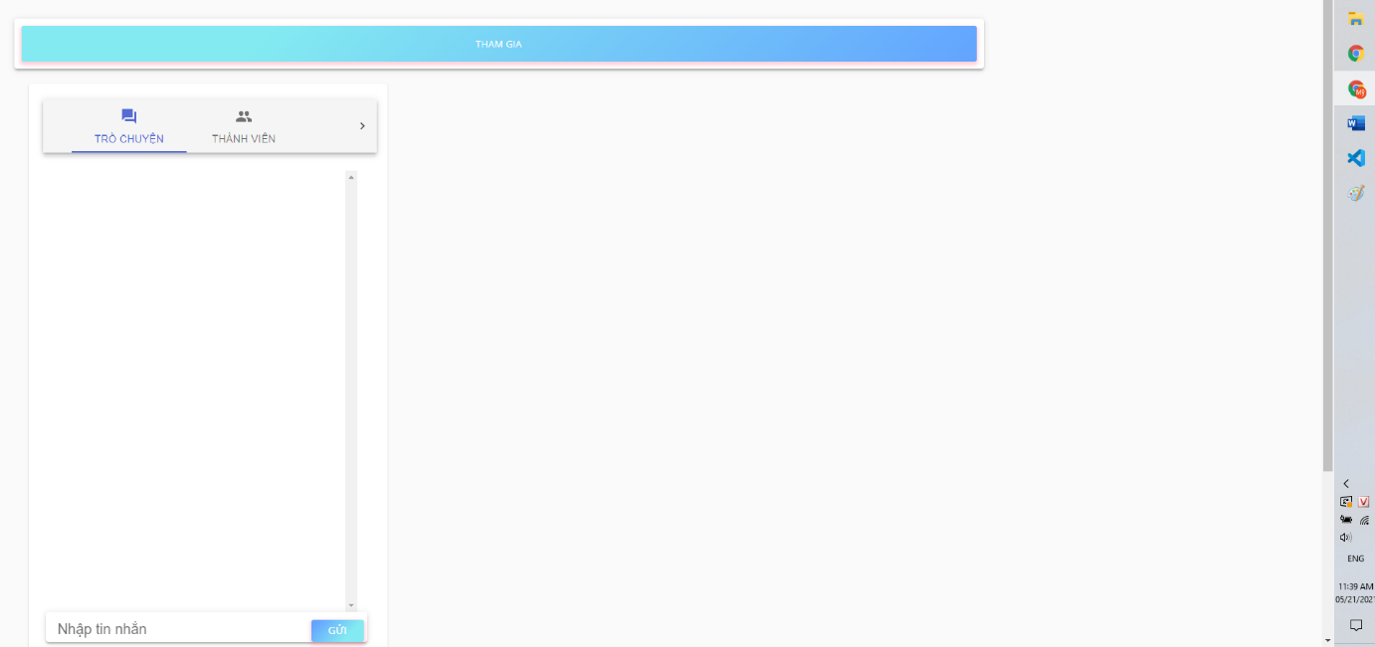

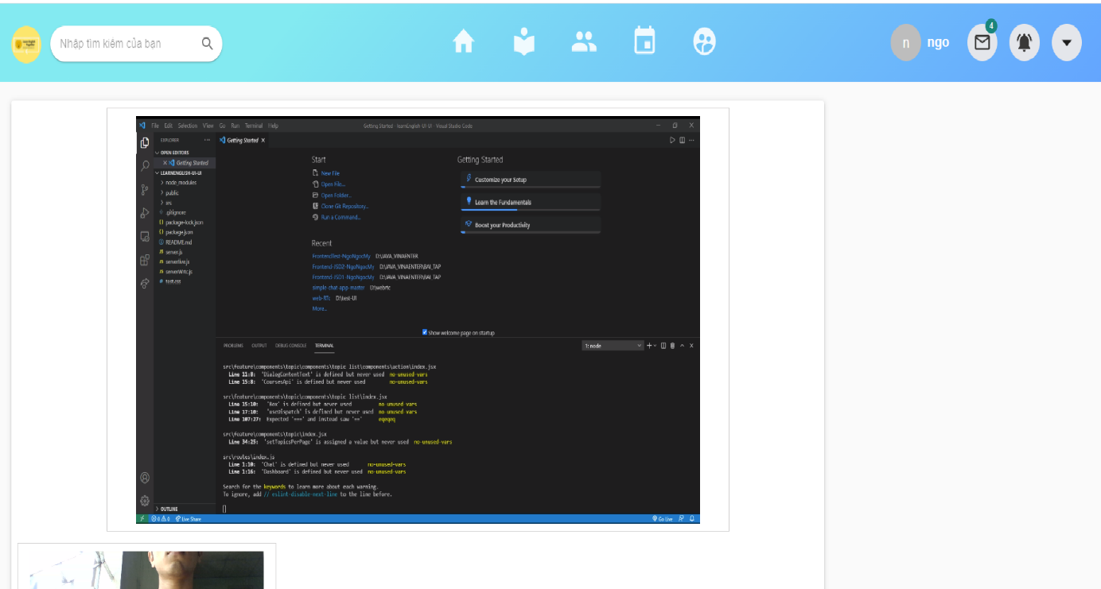

|  |  |  |  |  |
| --- | --- | --- | --- | --- |
| **Profile** | | | | |
| **No.** | **Field name** | **Type** | **Require** | **Target** |
| 1 | Button join | image | Font-size: 250px | Avatar of user |
| 2 | Menu room | List | Width: 450px;  Height: 70px;  Background color: Grey | Chat, record, record, members |
| 3 | Button share screen | Button | Heading: h2 tag  Font-size: 20px color:  Button: learn and delete course | When others click, my screen will share |
| 4 | Camera |  | Font-size: 13px;  Background color: orange; | back to the front of the computer screen |

2.7. Chat

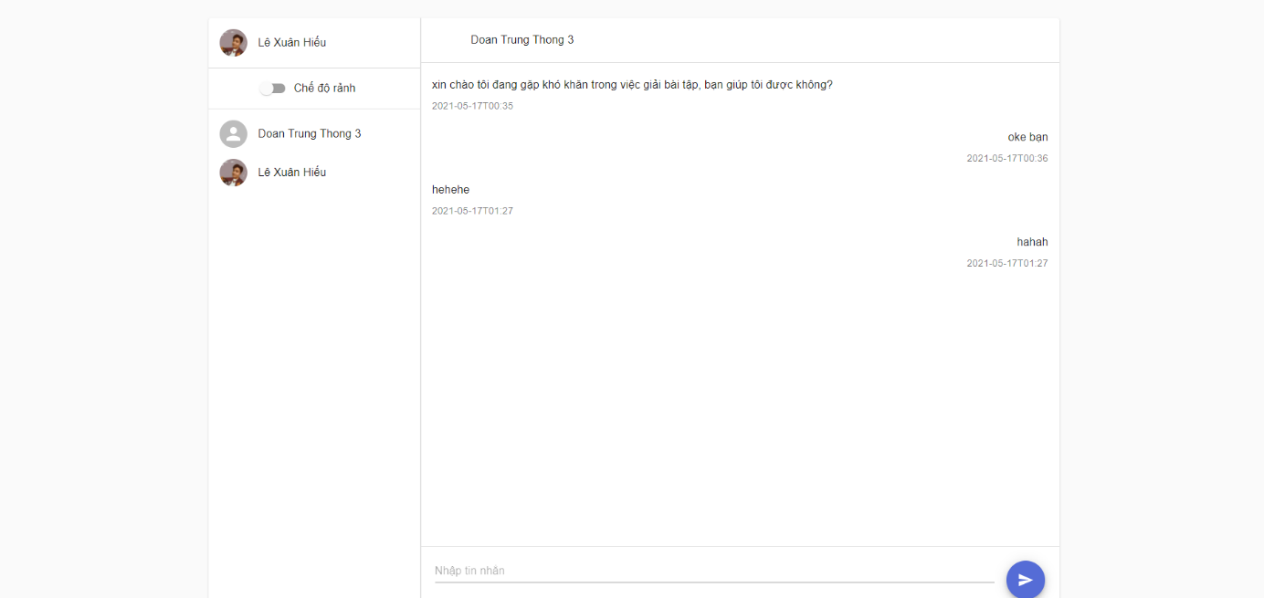

|  |  |  |  |  |
| --- | --- | --- | --- | --- |
| **Profile** | | | | |
| **No.** | **Field name** | **Type** | **Require** | **Target** |
| 1 | Avatar | image | Font-size: 250px | Avatar of user |
| 2 | Username | P tag | Font-size: 13px;  Font-weight: bold |  |
| 3 | Button sending | Button | Font-size: 13px;  Background color: blue; | When others click, message will send to receiver |
| 4 | Content message | Button | Font-size: 13px; |  |
| 5 | Time sending |  | Font-size: 12px; | Show real time sending |
| 6 | List friend | list | Font-size: 13px;  Avatar: Font-size: 250px;  Username: Font-size: 13px;  Font-weight: bold |  |